Experiment 8
TCP vs UDP Performance & Reliability

Lab 8 Objectives:
● Establish connections using TCP and UDP, compare reliability and performance.
Prerequisites: The prerequisites of this lab are-
● Basic understanding of TCP and UDP protocols.
● Familiarity with network sockets and data transmission.

Outcomes: By the end of this lab, students will be able to:
● Establish and test connections using TCP and UDP.
● Compare data reliability, latency, and throughput.
● Analyze packet loss and retransmission behavior.

TCP vs UDP Protocols
Feature | TCP | UDP
Connection Type | Connection-oriented | Connectionless
Reliability | Reliable data transfer with acknowledgment and retransmission | Unreliable, no guarantee of delivery
Ordering | Data packets arrive in order | No ordering guarantees
Error Handling | Error detection, retransmission, flow control | Basic error checking, no retransmission
Speed | Slower due to overhead | Faster, less overhead
Use Case Examples | Web browsing, email, file transfer | Video streaming, online games

Procedure
Step 1: Setup Client-Server Model for TCP and UDP
- Create a TCP server and TCP client that establish a connection and exchange data.
- Create a UDP server and UDP client to send and receive the same data without connection establishment.
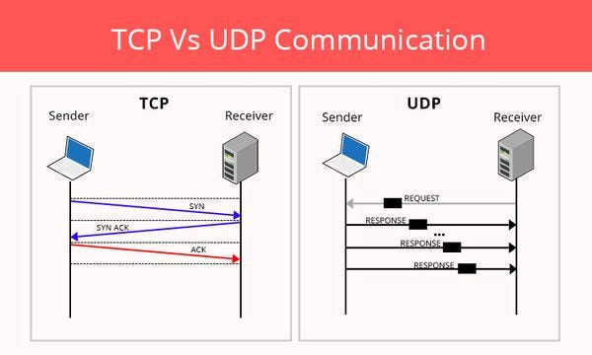

Step 2: Establish TCP Connection and Transfer Data
- TCP client connects to the server.
- Data is sent, and server acknowledges receipt.
- Ensure retransmission happens if packets are lost.
- Measure latency and throughput during data transfer.

Step 3: Establish UDP Connection and Send Data
- UDP client sends data packets to the server.
- No connection or acknowledgment.
- Measure latency and throughput for UDP transfer.

Step 4: Measure and Compare Performance Metrics
Metric | TCP | UDP
Latency | Higher due to connection setup and error checking | Lower, connectionless
Throughput | Moderate, due to retransmissions and flow control | Higher, less overhead
Packet Loss | Low, retransmissions recover lost packets | Higher, no retransmission
Reliability | High, ensures data delivery | Low, no delivery guarantees
Ordering | Guaranteed | Not guaranteed

Step 5: Analyze Packet Loss and Retransmission Behavior
- Use tools like Wireshark or Netcat to capture packets.
- Observe retransmission packets in TCP if any loss occurs.
- UDP packets lost are not retransmitted.
- Analyze how retransmissions affect overall performance and latency in TCP.

Sample Commands and Code Snippets

Netcat TCP Server
nc -l 1234

Netcat TCP Client
nc 192.168.1.10 1234
Netcat UDP Server
nc -u -l 1234

Netcat UDP Client
nc -u 192.168.1.10 1234

Observations and Results
- TCP ensures reliable data transfer but has more overhead, resulting in higher latency.
- UDP is faster but does not guarantee data delivery.
- Packet loss is observed in UDP, but TCP handles loss through retransmission.
- Depending on the application, either TCP or UDP is chosen balancing reliability and speed.

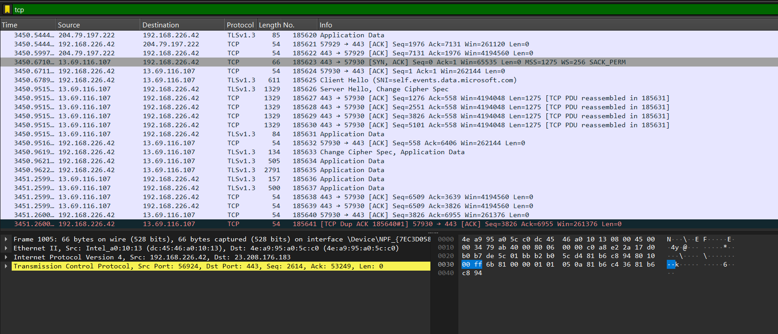
TCP in Wireshark

